Experienced In

|  |  |
| --- | --- |
| **HTML** | **CSS** |
| **JavaScript** | **MySQL** |
| **PHP** | **Cordova/PhoneGap** |
| **GitHub** | **WordPress** |

Work Experience

**IT Support June – July 2017**

at **Longacres Garden Centre**

Updating the website, overlooking social media pages (Instagram, Facebook and Twitter), setting up new e-commerce webpages, corrected tax codes so the company would stop paying VAT on zero VAT items on their website.

**Social Media Manager May – August 2017**

at **Tropical Britain**

Advising on website structure, visual layout, promotions, whilst creating an Instagram account to advertise the plants grown within the business alongside helping with the agricultural side of the company.

Profile

**Website Designer**

I am a final year computing student that is hoping to gain further experience in the web design industry to further my education. Learning whilst on the job would expand my knowledge of the work required and processes that businesses within the industry use from day-to-day.

I have experience in designing, developing, testing and hosting websites following strict guidelines set by clients working with their ideas, specifications and aspirations. I have used a variety of software and coding languages to complete these projects.

I am a confident, self-motivated web designer who is keen to work within a team of other talented, creative and passionate colleagues. I have excellent written and verbal communication skills whilst also being a systematic problem solver who enjoys challenges and can be depended on even under pressure.

Personal Details

* 07936 605582*

* CharlesdeK@hotmail.co.uk*

* Flat 5 St Swithins House, Trinity Street, Worcester, Worcestershire, WR1 2PW*

* charlesdekerckhove.github.io /index.html*

Additional Skills

*Social Media & Marketing*

*Facebook*

*Instagram*

*YouTube*

*Twitter*

*Snapchat*

*LinkedIn*

*Design Software*

*Photoshop*

*Illustrator*

*InDesign*

*General IT*

*Word*

*Excel*

*PowerPoint*

Past Achievements

* Duke of Edinburgh Silver & Bronze awards
* FA 1 Level Coaching Course
* Trained in Emergency First Aid by St John’s Ambulance
* Played competitive football for over ten years with local clubs & university teams

Charles de Kerckhove

Employment History

***Marks & Spencer’s Worcester (Worcestershire)***

*Customer Service Assistant July 2018 – Present*

*Baking bread, monitoring stock levels, achieving high levels of cleanliness, assisting customers and checking stock quantities.*

***Tiger Worcester (Worcestershire)***

*Customer Service Assistant October 2017 – January 2017*

*Operating tills, unloading deliveries, altering store layouts, training new employees and interacting with customers.*

***Waitrose West Byfleet (Surrey)***

*Customer Service Assistant June 2015 – April 2017*

*Replenishing stock, unloading deliveries, handling cash, operating tills, interacting with customers and training new employees.*

Education and Qualifications

University of Worcester 2016 – present

*BSc (Hons) Computing [Second year complete]*

Year 3: Practical Databases Applications | Computing Project

Cybersecurity | Advanced Web Applications Development

Drone Technology | Manging Cyber Risks

Year 2: Mobile Applications Development | Systems Analysis & Design

Web Applications Development | E-Business

Year 1: Web & Databases | Programming & Scripting

Creative Computing | Game Design

Salesian Sixth Form Surrey 2014 - 2016

A-Levels ICT **A\***

Business **A**

History **B**

Salesian School Surrey 2009 - 2014

GCSE 12 GCSEs including an A in Mathematics and a B in English Literature and English Language.

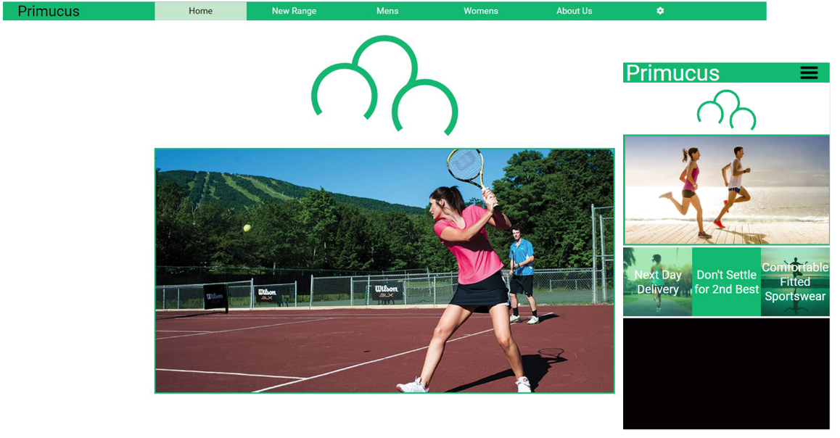Portfolio of Work

**Primucus Responsive Website**

This website was designed to be used as promotional material for the Primucus brand which sells modern sporting and exercise essentials. The website consists of 6 pages ranging from three product pages to a brief history of the company. It was built through a combination of HTML, CSS and JavaScript. It incorporated a responsive layout using media queries and percentage-based widths to allow multiple devices to use the website easily and comfortably.

The website contained a video with custom controls, the use of AJAX to POST and GET data alongside the implementation of a currency converter API. Moreover, a slideshow was included that cycles through examples of the products in action. The logo was also animated using a canvas-based animation. Local Storage was utilized for both a change in settings and to guarantee the adverts were not repeated on loading of a webpage.

__________________________________________________________________________________

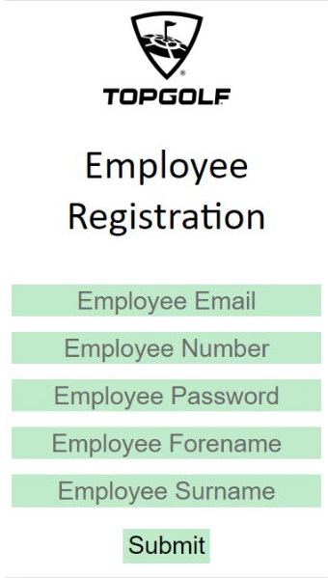**TopGolf Application**

I was tasked with the job of creating a training application for TopGolf Surrey, they desired a quiz-style mobile app that would have a database of questions relevant to each job role (bar staff, kitchen, runners etc). Each employee would need to be registered and depending on their job role receive access to relevant quizzes to test their knowledge with the results given to each employee and forwarded to their section manager. This project was done by a team of four where I held the role of both designer and developer of the database and mobile application. An agile approach was taken due to the close connections to the company allowing constant reviews and ideas to be shared continuously.

**For other examples of past projects please visit:** https://charlesdekerckhove.github.io/index.html#what